

Application Design Document

Family Organiser

Referred Coursework – 2019/20 Academic year

Stephen Daniel | ISAD251 | August 2020

Contents

ENTITY RELATIONSHIP DIAGRAM (ERD) 1

STORYBOARD 2

UNIFIED MODELING LAGUAGE (UML) 3

PEER VIEW 4

SCREENSHOTS 5

APPLICATION FACT SHEET 8

OTHER BROWSERS USED 8

IMPORTANT LINKS 9

# ENTITY RELATIONSHIP DIAGRAM (ERD)

Referred-Coursework-2019-2020-Family-Organizer

Entity Relationship Diagram

FAMILY APPOINTMENTS DEADLINES

FAMILY ID APPOINTMENT ID DEADLINE ID

FIRST NAME FAMILY ID FAMILY ID

LAST NAME APPOINTMENT DEADLINE

EMAIL WHEN WHEN BY

LOGIN NAME COMMENT COMMENT

LOGIN PASSWORD NOTE NOTE

# STORYBOARD

# UNIFIED MODELING LAGUAGE (UML)

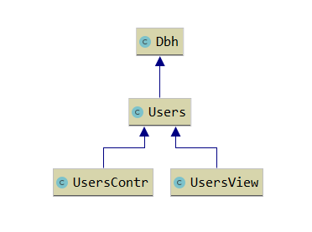

# PEER VIEW

# SCREENSHOTS

MAIN PAGE

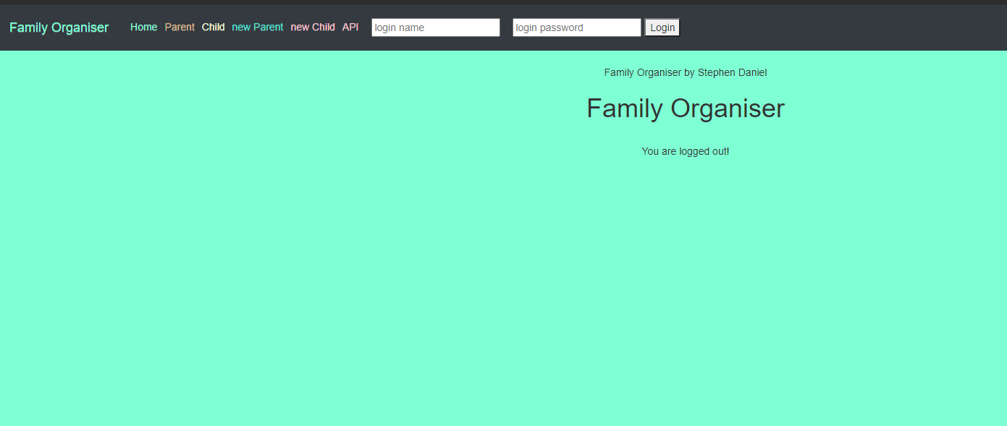

NEW PARENT

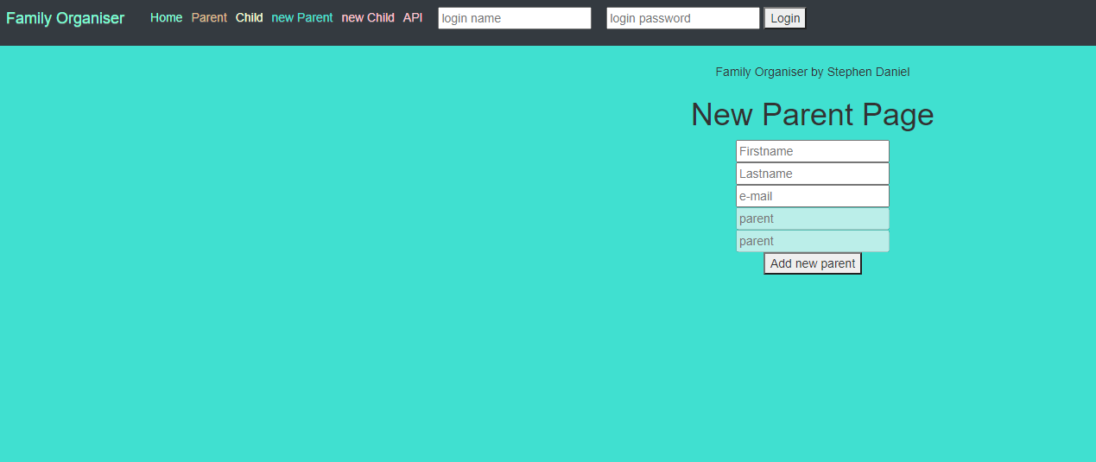

NEW CHILD

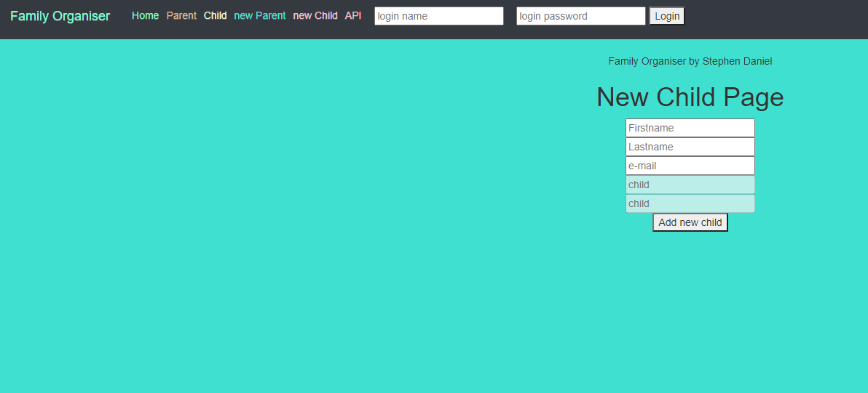

PARENT PAGE

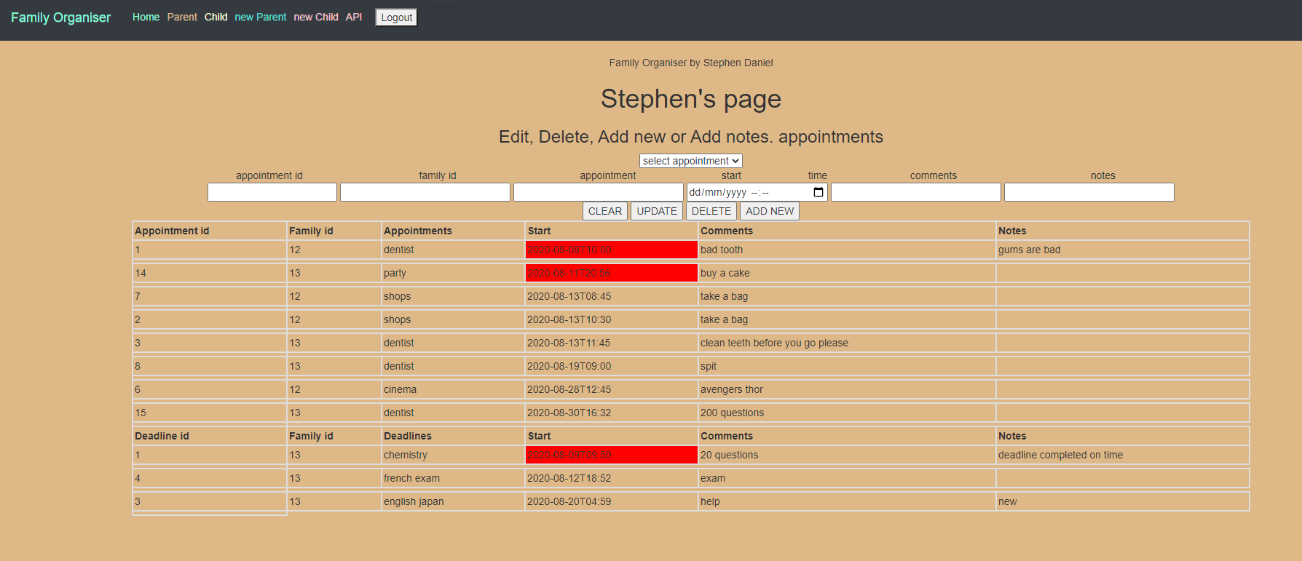

CHILD PAGE

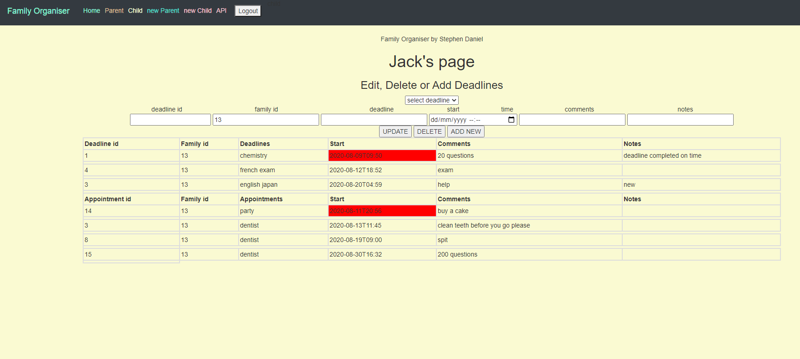

API PAGE

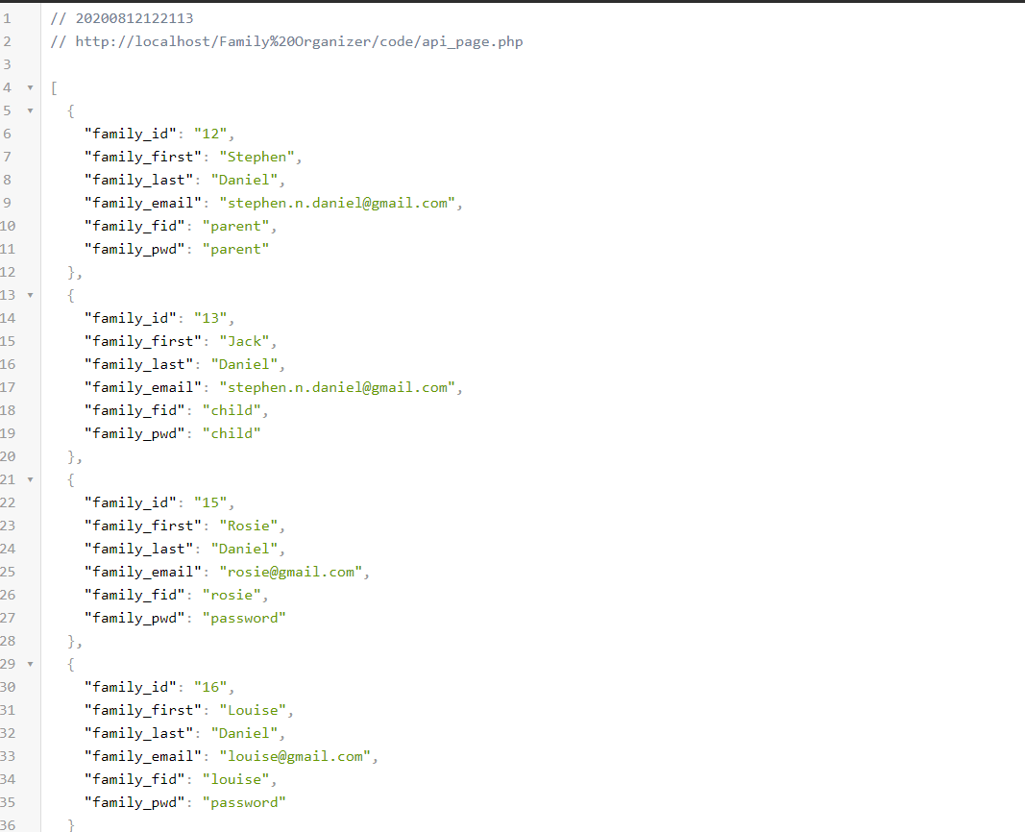

# APPLICATION FACT SHEET

The Family Organizer is an online diary for both parents and child. With their own login the user will be sent to their own page.

For this minium viable project, I have setup that all parents are admin. That passwords for the login page are kept simple for demostrating you must login and logout.

Login name: parent Login password: parent

Login name: child Login password: child

Parents will be able to view all appointments for all the family, along with the deadlines that their children have. They wont be able to amend any deadlines but can add new users, appoint new appointments to any family member, amend any appointment or just cancle, delete appointments. As a child you can view all your deadlines and appointments, add new deadlines with comments, amend your deadlines and delete dealines. Using the notes you can say if the deadline is complete.

Both users will be shown if a date has past by the change of colour to red. Parent will only then be able to add a note regardin that appointment.

All the details are store in a database.

# OTHER BROWSERS USED

Microsoft edge and Google chrome

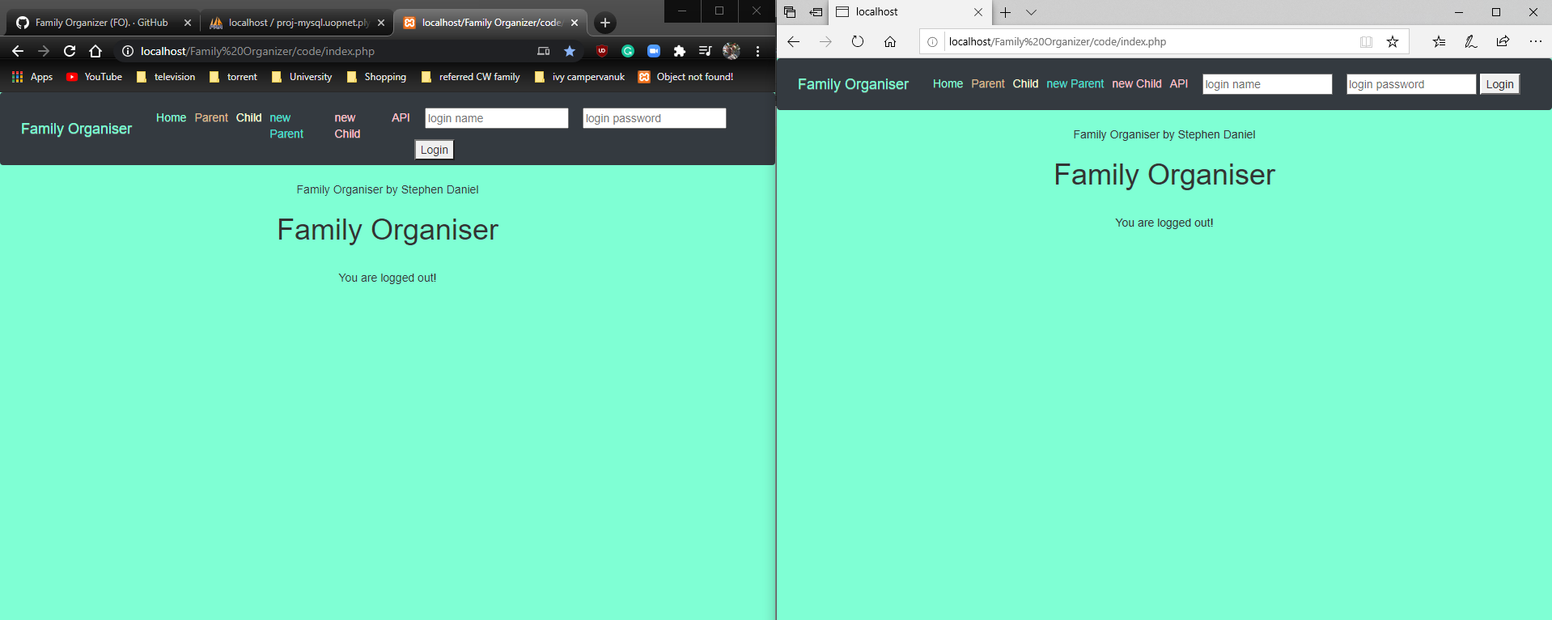

# IMPORTANT LINKS

GITHUB

<https://github.com/Stephen-Daniel/Referred-Coursework-2019-2020-Family-Organizer>

<https://github.com/Stephen-Daniel/Referred-Coursework-2019-2020-Family-Organizer/projects/1?add_cards_query=is%3Aopen>

YOUTUBE <https://youtu.be/VjY8X1Fgad8>

API http://localhost/Family%20Organizer/code/api_page.php